Creating an SQLite database with EAN Database content
This short article describes how to create a database from the EAN downloadable content using the SQLite format as a target. Technically you will get ALL available data from EAN using this solution and you can use it for mobile devices, however it may prove harder to manage and maintain for production environments than the MariaDB / MySQL offering we have available also on the documentation site. Please use the MariaDB solution for a more robust solution.
First you will need to make sure you are using the SQLite version 3 database format, or you can just download the latest one from its web site at https://sqlite.org
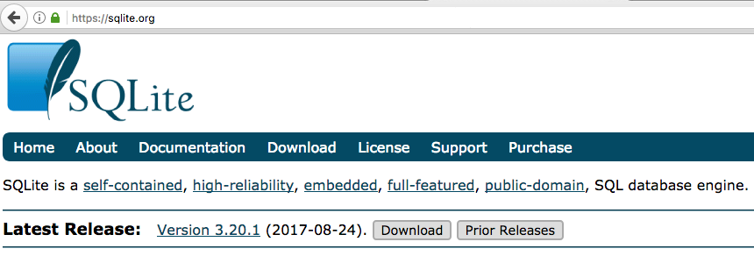

We should have the sqlite3 command line utility added to your operating system path, we can then verify the engine version:
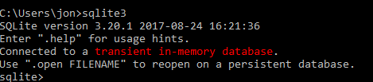
In this case (a Windows 10 computer) we can see that SQLite version is 3.20.1, so we are good to go!
There are basically just 2 steps required to use SQLite as your target database for imports. Let’s go over the required steps:
- Create the empty structure of the database, basically you will end up with and empty eanprod.db file that will hold all information. You will need to run a .sql script to create this empty file and its structure; as an alternative you can use the pre-created file included with this download.
- Refresh the data, basically download and refresh the data, you will probably need to run this step every time you need the latest information exposed by EAN. Due to the amount of data and depending on your Internet connection and speed of the machine you are trying to update, this process may take multiple hours.
Let’s examine each step in details.

Create empty database
For any refresh project you will need to create an empty database, in the case of SQLite this also means a file that will contains the information.
This step is easy to accomplish by using the SQLite command line utility, optionally you can use an SQLite graphical browser like DB Browser for SQLite.
In my case I created the subdirectory of /sqlite_data/ to save the information. Using the script is quite easy, just run a command like:
>sqlite3 {database_filename} < {script that create the database}
For our case it will be something like:
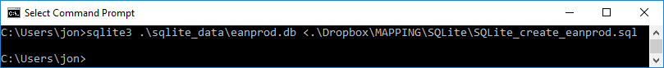
In just a few seconds you should have the file eanprod.db created. We can just list that directory to verify its creation.
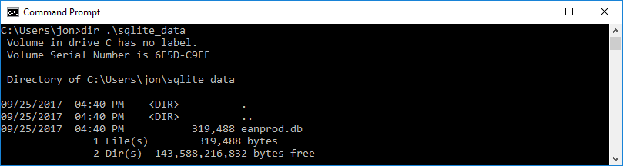
We could do a more technical verification by using the same sqlite3 utility connecting to the newly created database and verifying its tables with the .tables command.
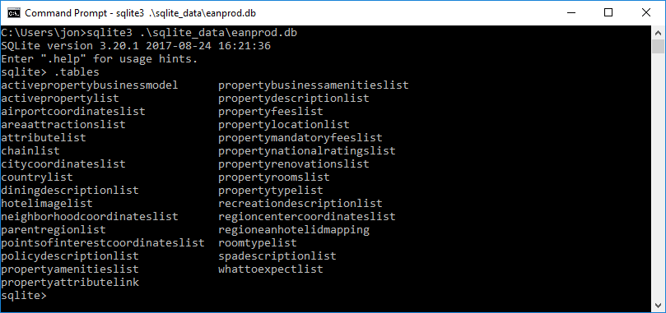
We now have an empty structure ready to receive the data from the EAN website. Remember to exit the SQLite3 utility with the .q command.

Refreshing the Data
Now that we have an empty structure or an existing one (even if it contains data) we can always pull the latest data by running the “refresh script”. Before we do so, we need to understand that the refresh script is created in the Linux platform (so we need a compatibility layer) and that it uses a Python Language script, so we will need to have the proper runtime installed.
To cover the Python language requirement; we should go to the official python.org web site at: https://www.python.org/ to download:
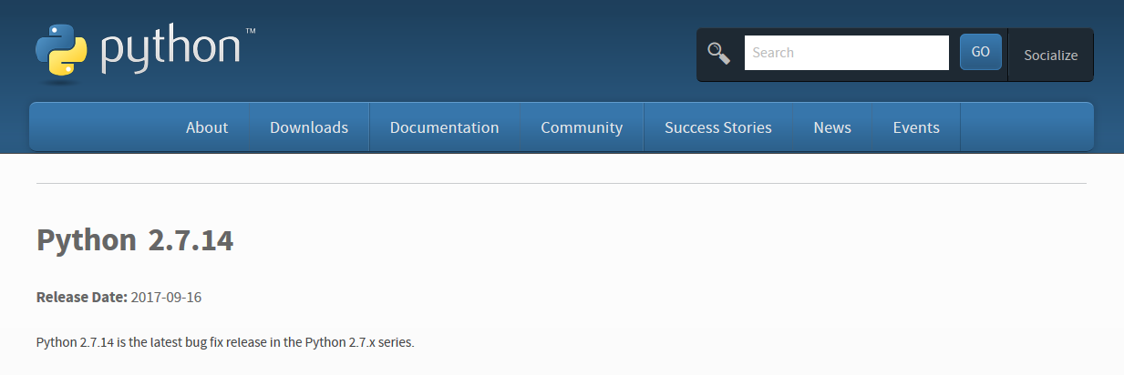
In our case the latest Python 2 version is Python 2.7.14. If you are new to python you should know that there are two concurrent versions: 2 & 3. They are NOT compatible; this process was design to work with Python 2 so please use the latest of that version.
As we are working on a Windows 10 computer we download the file named: Windows x86-64 MSI installer.
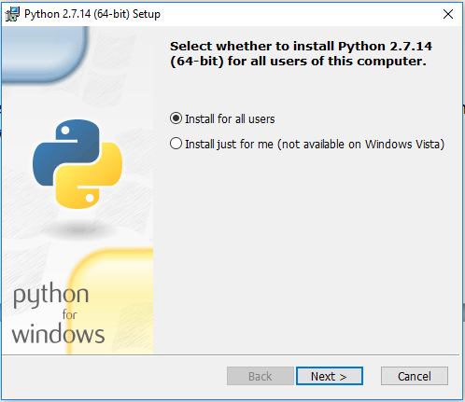

Install it for all users, and verify by running the following command on the cmd prompt:
python –version
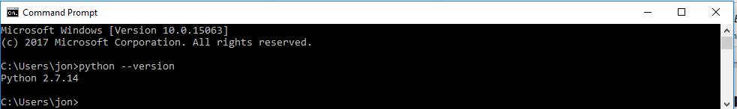
Once we verify it is the correct version, we should move into running the refresh process so we can populate our SQLite database.

The first step here will be to install the Unix compatibility layer so we can launch the script, if you are running this script in MAC or Linux you just need the script to be turn into executable.

In Windows we use the excelent Cygwin project to install the compatibility layer. Go to the project offical site: https://cygwin.com/install.html
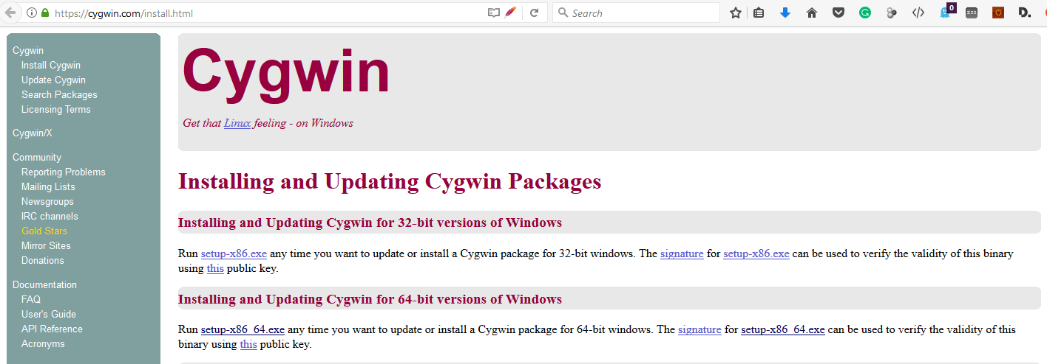
Just run the default install, but make sure the package called md5deep is installed as it is required to generate the downloadable content signatures and compare them.

We also need some aditional utilities to be downloaded and place it in a directory that is (or you make it) part of the system path.

Utility | URL to download it from | Actual file we call
cURL - command line tool and library for transferring data with URLs | https://curl.haxx.se/ | curl.exe
Unzip – zip file format extractor | http://www.stahlworks.com/dev/unzip.exe | unzip.exe

In our installation we just copy the “Actual file we call” to the c:\windows directory. AFTER CHANGING AND ADJUSTING ALL DECLARATION OF VARIABLES IN THE .SH SCRIPT. The script is well documented and you can see all utilities that need to be presently installed for it to work. Now to launch the refresh process just start the Cygwin64 terminal prompt by double clickimg its icon:

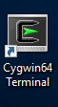

I normaly change into the user home’s directory, then run the refresh script by the command:
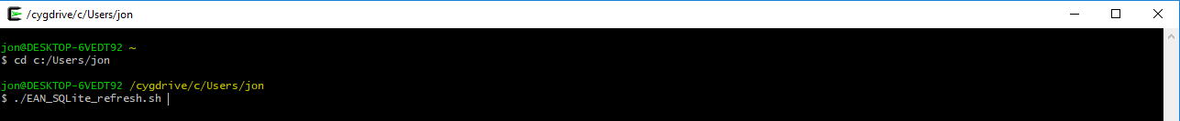
./EAN_SQLite_refresh.sh

You should see the process running: downloading content and uploading it to the SQLite database file.

The first thing that it will do is to download the files from our site using the cURL command line utility. You should see something like:

The script will tell you the download time and progress, you can also see if the file is different from the last time you downloaded. The "uploading..." line will be the indicator that the script is sending data to the database. Actual time will be affected by network connection and database engine performance but expect a few hours of work.
At the end of the script you will get a list of all tables with the amount of records, as well as the lines of records in each downloaded file.

Schedule the refresh job
To schedule the refresh job you should use your operating system default sub-system. In the case of Windows 10 this is schtasks.exe. You only need to do this step if you will like it to autorefresh the information, if not you may run it on-demand as needed. You can find documentation here: https://msdn.microsoft.com/en-us/library/windows/desktop/bb736357(v=vs.85).aspx

